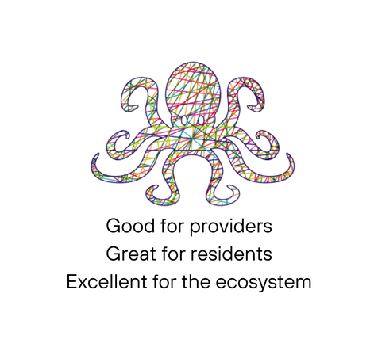

O C T O P U S 10

Date:
Time
21.05.2024
14:00 - 16:30
(Free to arrive from 12:30 for self-guided walk around the Zoo)

@ ZSL
Prince Albert Suite
London Zoo (Main entrance)
Outer Circle
Regent’s Park
NW1 4RY

- Opening Statement – Dr Saul Kaufman (3 min)
- Introductions – YOU (15 min)
- CHWW case study - Sheuly Chowdhury (5 min)
- Green Prescribing – Patrick Conlon (10 min)
- Well, well, well.. – Dr Ben Holden (10 min)
- Speed Dating – YOU (30~ min)
Red = Local Authority, Blue = Academia/Research/ICB, Yellow = VCSE, Green = Health
- Contextualisaing the Octopus – Dr Affy Safa (10 min)
- From the Hyperlocal to the National – Dr Simon Opher MP (3 min)

