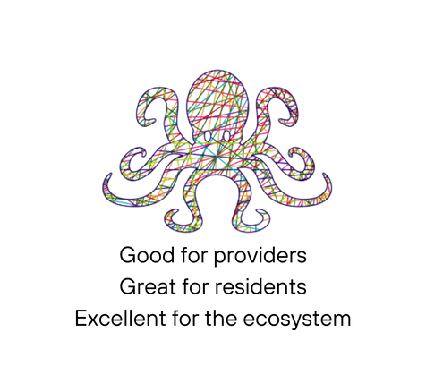

O C T O P U S 13

Date:
Time
11.02.2026
14:00 – 17:00

AGENDA
Grand Junction
Rowington Close
London
W2 5TF

- Welcome – Dr Saul Kaufman (5 min)
- Introductions – YOU (30 min)
- Remembering Khadega – The Abbey Centre (5 min)
- CHWW Case Study – Nahima Begum (10 min)
- Dementia Tapestry: Octopus Dementia Working Group – Pallavi Nair (10 min)
- Speed Dating – YOU (30 min)
Red = Local Authority, Blue = Academia/Research, Yellow = VCSE, Green = Health
- Univeral Wellbeing Index – Ben Holden (5 min)
- CHWW Evaluation Data – Matt Harris (20 min)
- She Heals – Jodie Chan (10 min)
- Closing Remarks – (<1 min)

